Directional Axial Magnetic Propulsion Systems TM

Proprietary Magnetic Shock Mitigation Technology

Made in the USA

Technology is Fashion
Our job is to make you feel as good as you look
We Want our shoes to be as Smart as Our Phones
Fashion Integrated Technology Now (FITN)

Benefits

Reduces Dynamic Heel Strike over 68%

Walk Ten Miles Save Your Body the Shock of Seven

DAMPS market branding adds designated value for the licensor

2016 Testing with the Office of Naval Research (ONR) Navy Seals yields shock mitigation testing data for a FDA 510 (k) Medical Device for the Prevention and Treatment of Lower Extremity Injury and Plantar Fasciitis (heel strike injury)

Performance Tested USSOCOM

United States Special Operation Forces (SOF) 2004 to present

www.DAMPS.com

F Scan Testing with SOF 2004

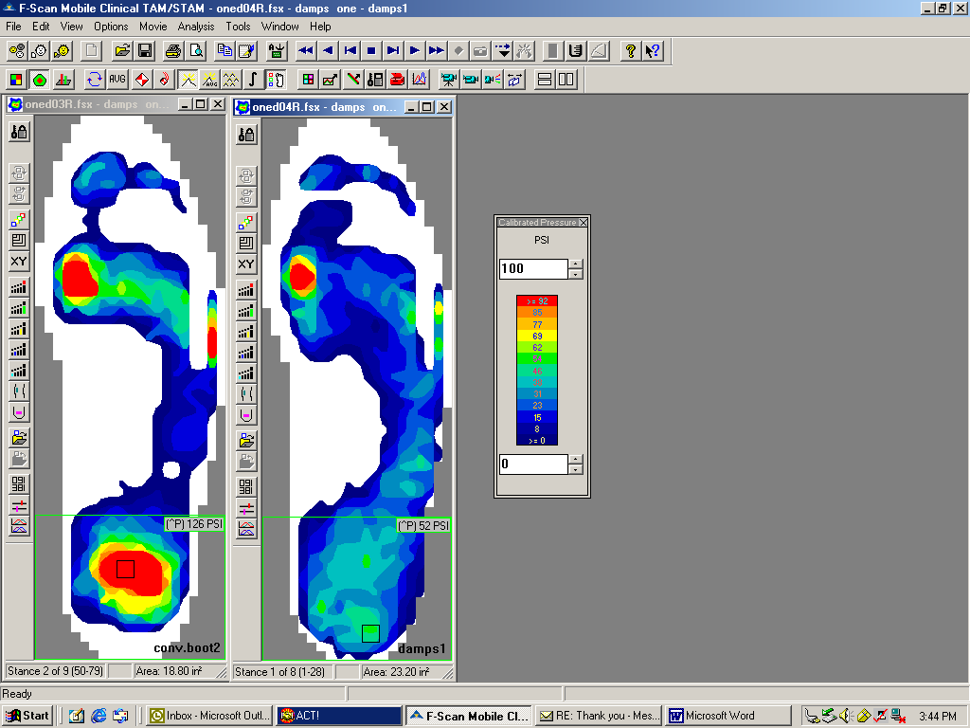

Conventional Boots in Red 126 p.s.i. DAMPS in Blue 52 p.s.i.

